**Explore Weather Trends**

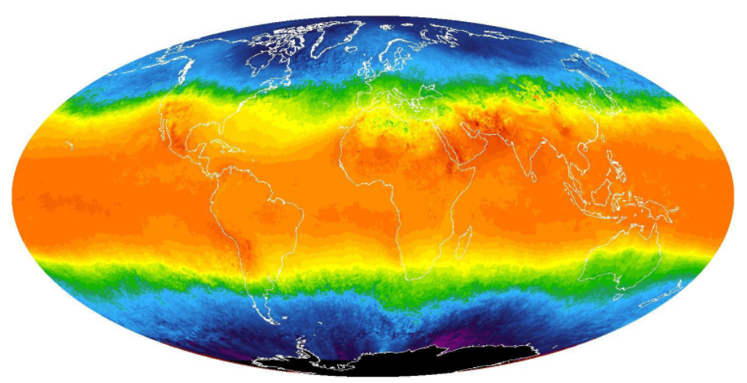

Name: Mahmoud Esmail Fouad  
Cairo, Egypt  
22,Nov,2018**Goals of the Project:**

* Extracting Data from database using SQL Queries and import it to CSV file.
* create a visualization using a line chart describing the similarities and differences between global temperature trends and local temperature trends in Cairo “where I live”.
* Making Observations on the chart that describes weather Trends.

**Tools Used:**

1. SQL Queries: To extract out data from the database that exists in udacity’s workspace
2. MS Excel: To plot a line chart in order to describe the similarities and differences between local and global temperatures

**Procedures:**

1. I wrote a SQL query to extract data From city_data Table this data include (year, city, avg_tmp).  
   after I Checked the existence of the desired city (cairo) from city_list Table I wrote WHERE clause in order to filter the results in the last 20 years just for the purpose of taking a small sample and making clear investigations on it, In My Opinion taking a lot of date, nearly about 205 Years average temperatures will not allow me to make clear observations after plotting the graph.

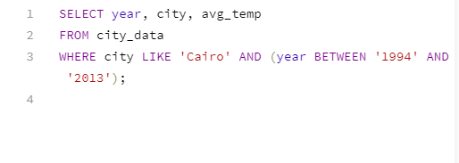

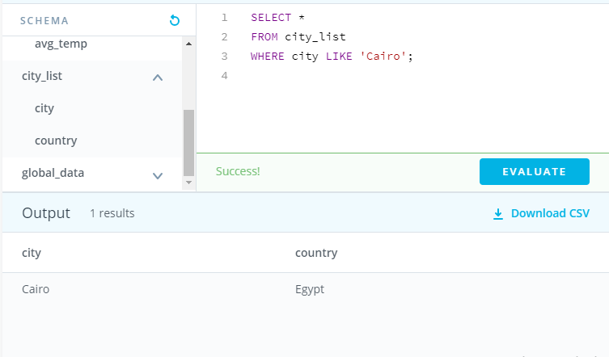

1. Downloaded the CSV file for the average local temperatures and I Took a 5 year moving average for the average temp in order to smooth out the data and make investigation on it. Instead of leaving the data sharpened  
     
   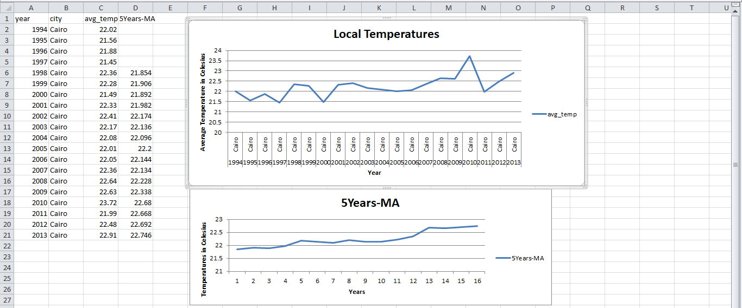

NOTE: upper graph for average local temperature before taking the moving average  
and lower graph after taking the moving average.

1. I wrote a SQL query to extract data From global_data Table this data include (year, avg_tmp).  
   for the last 20 years from 2013 to make a clear comparisons between local and global data, so the samples in the two tables must be equal to be accurate so I extracted 20 results from both tables

(local and global)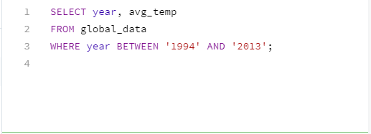

1. Downloaded the CSV file for the average global temperatures and I Took a 5 year moving average for the average temp in order to smooth out the plotted graph

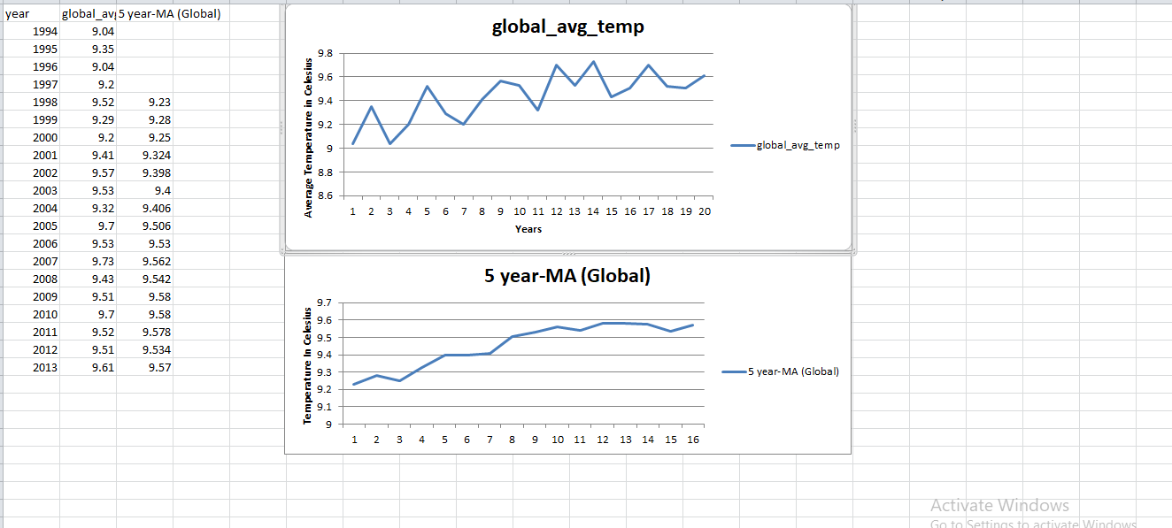

1. Finally, I Copied the numbers that I calculated in 5 Year –MA column of Local temperatures excel sheet and 5year-MA column of global_avg_temp excel sheet   
   and the copied columns were added into a new excel sheet and I used it to make a graph explaining the differences between the temperatures  
   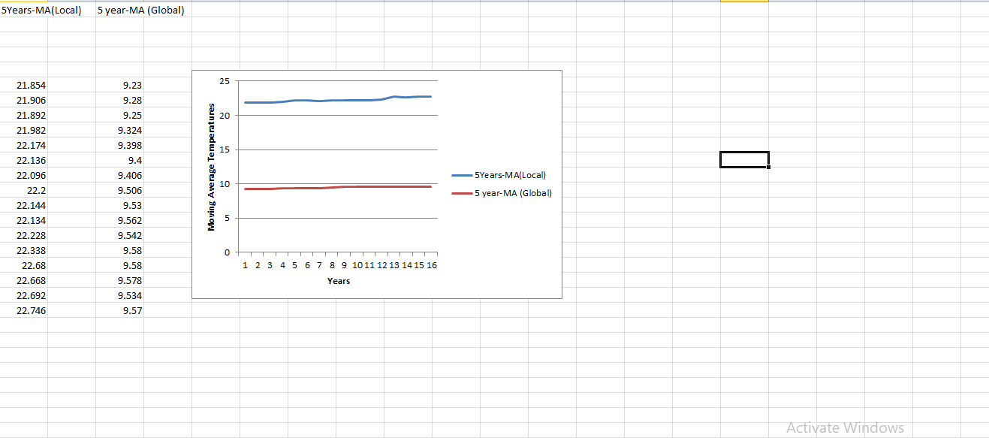

**Observations:**

1. Huge difference between local temperature and global temperature, the local temperature is much bigger, it’s seems that cairo is hotter than the global temp because in global temperature we took to much averages of many cities in denominator so the average became smaller, but that does not mean that cairo is hotter than every city in the world.  
    In Other Words: Correlation Is not a causation.
2. From line charts, There’s a constant Increase “the trend is always going upward” in both local and global temperature and that indicates that there will be a huge climate change will happen across the globe in the upcoming years
3. When I Took the 5 year MA in both graph of local and global the crest and troughs begun to disappear and the variation between temperatures appear to be less variant
4. In Local temperatures graph( the upper graph) if measured the difference between every crest and trough we will realize that the difference increases as we move rightwards over years

**Resources Helped Me to finish the project:**

<https://www.youtube.com/watch?v=ZVqP6MCGhfQ>

how to change chart title and axis title  
  
<http://www.sussex.ac.uk/ei/internal/forstudents/engineeringdesign/studyguides/techreportwriting>  
how to write a technical report